**Ticket Booking System**

# Tasks 1: Database Design:

1. Create the database named "TicketBookingSystem"

Ans) CREATE DATABASE TicketBookingSystem;

USE TicketBookingSystem;

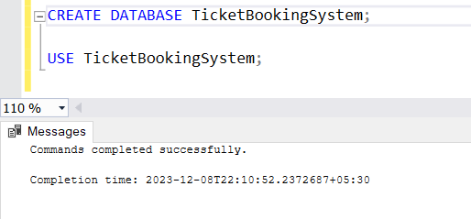

1. Write SQL scripts to create the mentioned tables with appropriate data types, constraints, and relationships.
   * Venu
   * Event
   * Customers
   * Booking

Ans)

-- Create Venu Table

CREATE TABLE Venu (

venue_id INT PRIMARY KEY,

venue_name VARCHAR(255),

address VARCHAR(255)

);

-- Create Event Table

CREATE TABLE Event (

event_id INT PRIMARY KEY,

event_name VARCHAR(255),

event_date DATE,

event_time TIME,

venue_id INT,

total_seats INT,

available_seats INT,

ticket_price DECIMAL(10, 2),

event_type VARCHAR(50),

booking_id INT

);

-- Create Booking Table

CREATE TABLE Booking (

booking_id INT PRIMARY KEY,

customer_id INT,

event_id INT,

num_tickets INT,

total_cost DECIMAL(10, 2),

booking_date DATE

);

-- Create Customer Table

CREATE TABLE Customer (

customer_id INT PRIMARY KEY,

customer_name VARCHAR(255),

email VARCHAR(255),

phone_number VARCHAR(15),

booking_id INT

);

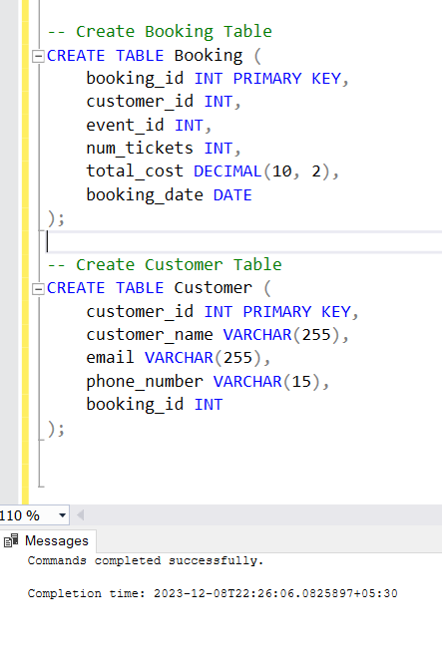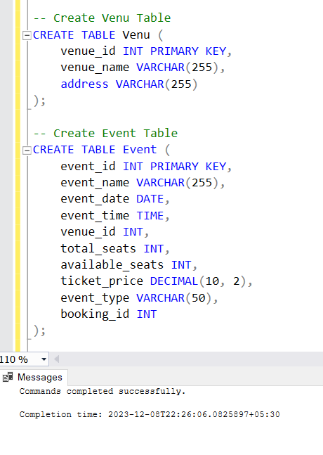

1. Create an ERD (Entity Relationship Diagram) for the database.

Ans)

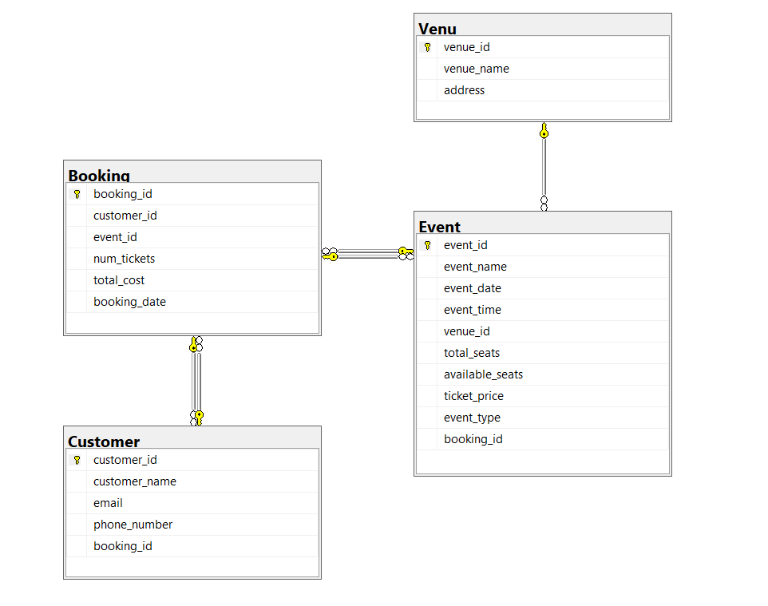

1. Create appropriate Primary Key and Foreign Key constraints for referential integrity.

Ans)

ALTER TABLE Customer

ADD FOREIGN KEY (booking_id) REFERENCES Booking(booking_id);

ALTER TABLE Booking

ADD FOREIGN KEY (customer_id) REFERENCES Customer(customer_id),

FOREIGN KEY (event_id) REFERENCES Event(event_id);

ALTER TABLE Event

ADD FOREIGN KEY (venue_id) REFERENCES Venu(venue_id),

FOREIGN KEY (booking_id) REFERENCES Booking(booking_id);

-- Add CHECK constraint for event_type

ALTER TABLE Event

ADD CHECK (event_type IN ('Movie', 'Sports', 'Concert'));

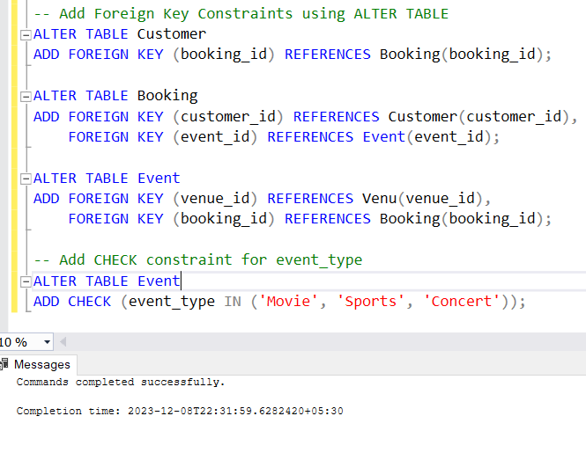

# Tasks 2: Select, Where, Between, AND, LIKE:

1. Write a SQL query to insert at least 10 sample records into each table.

Ans)

-- Insert sample records into Venu Table

INSERT INTO Venu (venue_id, venue_name, address) VALUES

(1, 'Grand Theater', '123 Main Street, Cityville'),

(2, 'City Arena', '456 Center Avenue, Townsville'),

(3, 'Sports Stadium', '789 Stadium Road, Sportstown'),

(4, 'Film Palace', '101 Movie Lane, Cinemaville'),

(5, 'Concert Hall', '202 Melody Street, Harmonytown'),

(6, 'Community Center', '303 Social Square, Gatherburg'),

(7, 'Live Lounge', '404 Entertainment Avenue, Showville'),

(8, 'Cinematic Complex', '505 Film Street, Filmington'),

(9, 'Soccer Park', '606 Goal Street, Kicksville'),

(10, 'Music Dome', '707 Harmony Road, Concertburg');

-- Insert sample records into Event Table

INSERT INTO Event (event_id, event_name, event_date, event_time, venue_id, total_seats, available_seats, ticket_price, event_type, booking_id) VALUES

(1, 'Movie Night: Inception', '2023-01-15', '18:00:00', 1, 150, 120, 2220.00, 'Movie', NULL),

(2, 'Concert: Acoustic Vibes', '2023-02-20', '20:00:00', 2, 300, 250, 1235.00, 'Concert', NULL),

(3, 'Soccer Match: City Rivals', '2023-03-25', '19:30:00', 3, 200, 180, 1525.00, 'Sports', NULL),

(4, 'Movie Night: The Great Gatsby', '2023-04-10', '21:00:00', 4, 120, 80, 1555.00, 'Movie', NULL),

(5, 'Concert: Pop Explosion', '2023-05-05', '17:45:00', 5, 250, 200, 3330.00, 'Concert', NULL),

(6, 'Live Music: Jazz Evening', '2023-06-12', '19:00:00', 6, 300, 280, 1440.00, 'Concert', NULL),

(7, 'Basketball Game: Finals', '2023-07-08', '18:30:00', 7, 350, 300, 1330.00, 'Sports', NULL),

(8, 'Movie Night: Casablanca', '2023-08-20', '20:15:00', 8, 150, 120, 2220.00, 'Movie', NULL),

(9, 'Soccer Match: International Clash', '2023-09-18', '19:45:00', 9, 200, 180, 1225.00, 'Sports', NULL),

(10, 'Concert: Rock Revolution', '2023-10-30', '22:00:00', 10, 250, 200, 3310.00, 'Concert', NULL);

-- Insert sample records into Customer Table

INSERT INTO Customer (customer_id, customer_name, email, phone_number, booking_id) VALUES

(1, 'John Doe', 'john.doe@email.com', '555-1234', NULL),

(2, 'Jane Smith', 'jane.smith@email.com', '555-5678', NULL),

(3, 'Robert Johnson', 'robert.j@email.com', '555-9012', NULL),

(4, 'Samantha Brown', 'samantha.b@email.com', '555-3456', NULL),

(5, 'Chris Miller', 'chris.m@email.com', '555-7890', NULL),

(6, 'Emma White', 'emma.w@email.com', '555-2345', NULL),

(7, 'Michael Davis', 'michael.d@email.com', '555-6789', NULL),

(8, 'Olivia Taylor', 'olivia.t@email.com', '555-1234', NULL),

(9, 'Daniel Wilson', 'daniel.w@email.com', '555-5678', NULL),

(10, 'Sophia Adams', 'sophia.a@email.com', '555-9012', NULL);

-- Insert sample records into Booking Table

INSERT INTO Booking (booking_id, customer_id, event_id, num_tickets, total_cost, booking_date) VALUES

(1, 1, 1, 2, 4440.00, '2023-01-15'),

(2, 2, 2, 3, 3705.00, '2023-02-20'),

(3, 3, 3, 1, 1525.00, '2023-03-25'),

(4, 4, 4, 4, 6220.00, '2023-04-10'),

(5, 5, 5, 2, 6660.00, '2023-05-05'),

(6, 6, 6, 3, 4320.00, '2023-06-12'),

(7, 7, 7, 5, 6650.00, '2023-07-08'),

(8, 8, 8, 1, 2220.00, '2023-08-20'),

(9, 9, 9, 2, 2450.00, '2023-09-18'),

(10, 10, 10, 3, 9930.00, '2023-10-30');

-- Update Booking Table with correct booking_id values

UPDATE Event SET booking_id = 1 WHERE event_id = 1;

UPDATE Event SET booking_id = 2 WHERE event_id = 2;

UPDATE Event SET booking_id = 3 WHERE event_id = 3;

UPDATE Event SET booking_id = 4 WHERE event_id = 4;

UPDATE Event SET booking_id = 5 WHERE event_id = 5;

UPDATE Event SET booking_id = 6 WHERE event_id = 6;

UPDATE Event SET booking_id = 7 WHERE event_id = 7;

UPDATE Event SET booking_id = 8 WHERE event_id = 8;

UPDATE Event SET booking_id = 9 WHERE event_id = 9;

UPDATE Event SET booking_id = 10 WHERE event_id = 10;

-- Update Customer Table with correct booking_id values

UPDATE Customer SET booking_id = 1 WHERE customer_id = 1;

UPDATE Customer SET booking_id = 2 WHERE customer_id = 2;

UPDATE Customer SET booking_id = 3 WHERE customer_id = 3;

UPDATE Customer SET booking_id = 4 WHERE customer_id = 4;

UPDATE Customer SET booking_id = 5 WHERE customer_id = 5;

UPDATE Customer SET booking_id = 6 WHERE customer_id = 6;

UPDATE Customer SET booking_id = 7 WHERE customer_id = 7;

UPDATE Customer SET booking_id = 8 WHERE customer_id = 8;

UPDATE Customer SET booking_id = 9 WHERE customer_id = 9;

UPDATE Customer SET booking_id = 10 WHERE customer_id = 10;

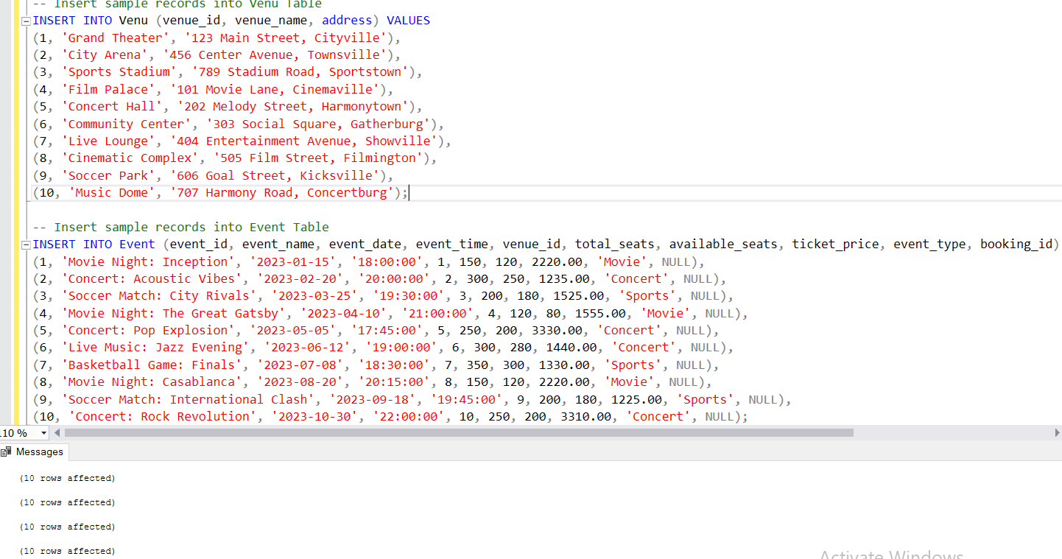

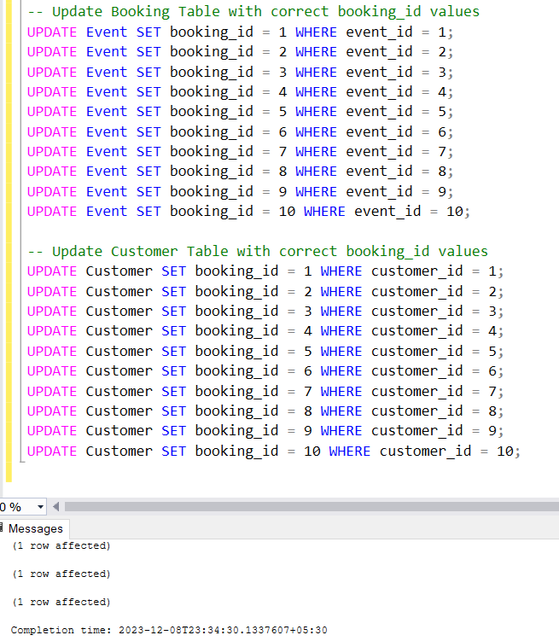 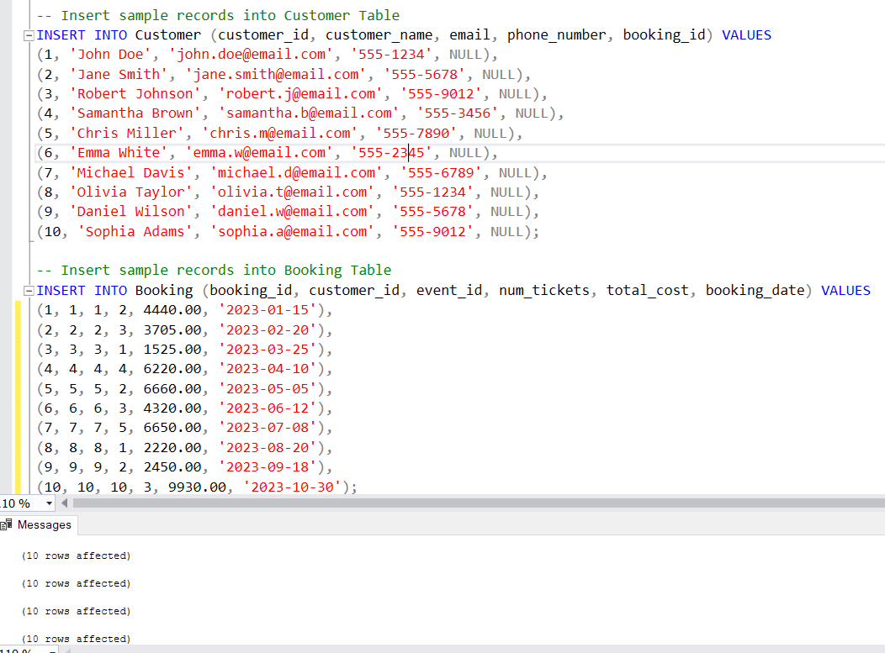

1. Write a SQL query to list all Events.

Ans) SELECT * FROM Event;

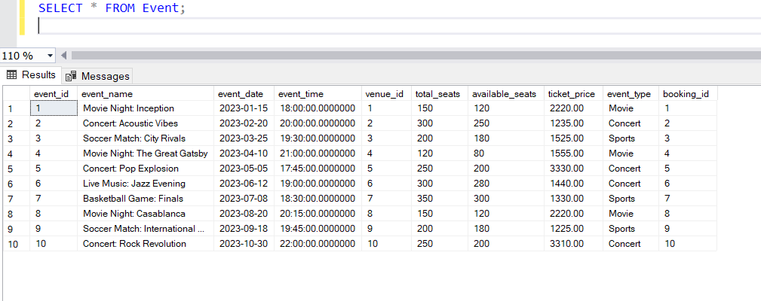

1. Write a SQL query to select events with available tickets.

Ans) SELECT * FROM Event WHERE available_seats > 0;

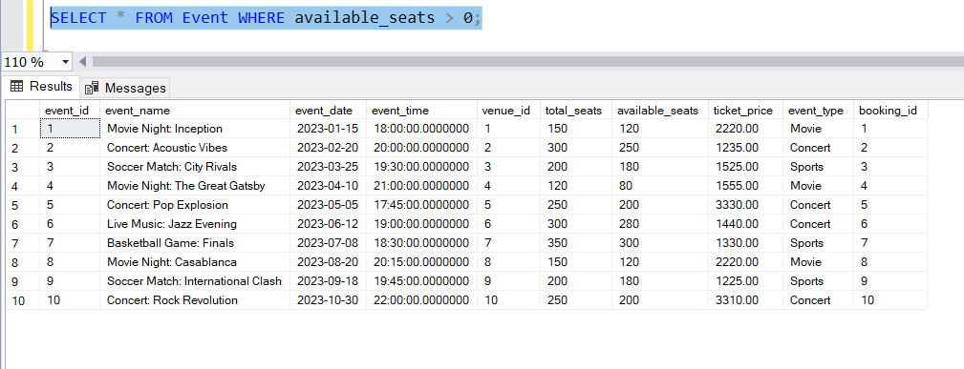

1. Write a SQL query to select events name partial match with ‘cup’.

Ans) SELECT * FROM Event WHERE event_name LIKE '%cup%';

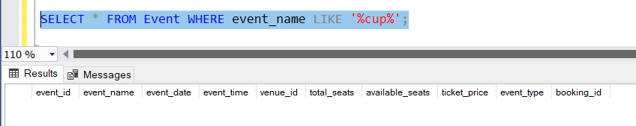

1. Write a SQL query to select events with ticket price range is between 1000 to 2500.

Ans) SELECT * FROM Event WHERE ticket_price BETWEEN 1000 AND 2500;

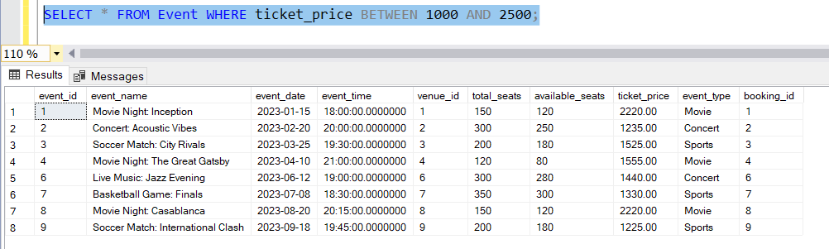

1. Write a SQL query to retrieve events with dates falling within a specific range.

Ans) SELECT * FROM Event WHERE event_date BETWEEN '2023-01-01' AND '2023-05-31';

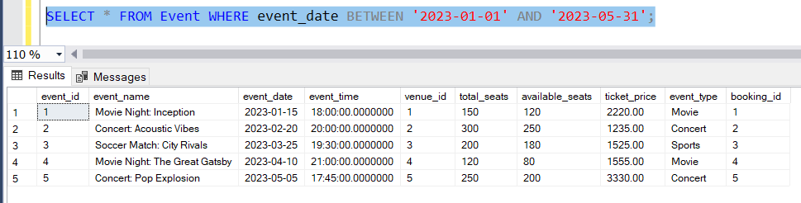

1. Write a SQL query to retrieve events with available tickets that also have "Concert" in their name.

Ans) SELECT * FROM Event WHERE available_seats > 0 AND event_name LIKE '%Concert%';

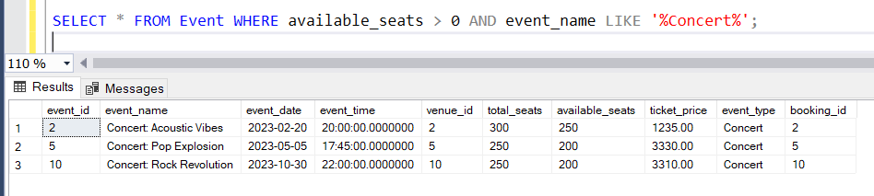

1. Write a SQL query to retrieve users in batches of 5, starting from the 6th user.

Ans) SELECT * FROM Customer ORDER BY customer_id OFFSET 5 ROWS FETCH NEXT 5 ROWS ONLY;

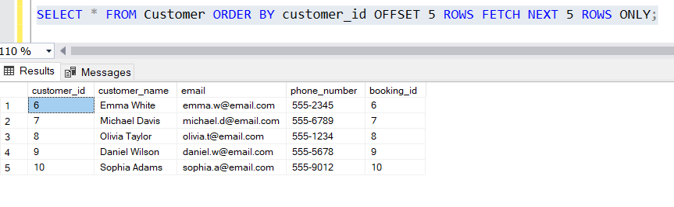

1. Write a SQL query to retrieve bookings details contains booked no of ticket more than 4.

Ans) SELECT * FROM Booking WHERE num_tickets > 4;

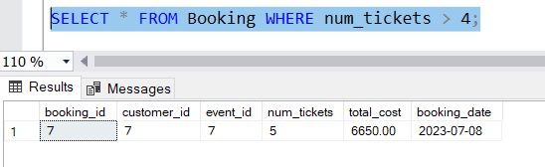

1. Write a SQL query to retrieve customer information whose phone number end with ‘000’

Ans) SELECT * FROM Customer WHERE phone_number LIKE '%000';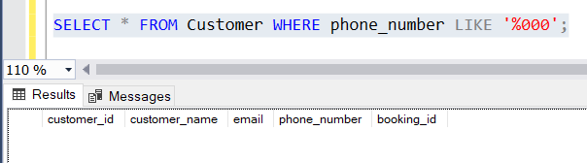

1. Write a SQL query to retrieve the events in order whose seat capacity more than 15000.

Ans) SELECT * FROM Event WHERE total_seats > 15000 ORDER BY total_seats;

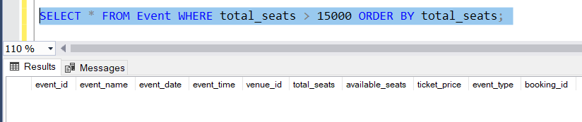

1. Write a SQL query to select events name not start with ‘x’, ‘y’, ‘z’

Ans) SELECT * FROM Event WHERE NOT event_name LIKE '[x-z]%';

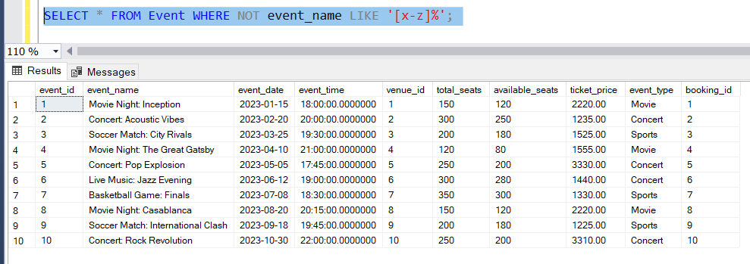

# Tasks 3: Aggregate functions, Having, Order By, GroupBy and Joins:

1. Write a SQL query to List Events and Their Average Ticket Prices.

Ans) SELECT event_name, AVG(ticket_price) AS average_ticket_price

FROM Event GROUP BY event_name;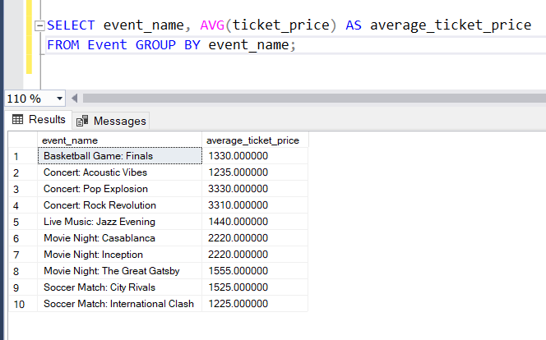

1. Write a SQL query to Calculate the Total Revenue Generated by Events.

Ans) SELECT SUM(total_cost) AS total_revenue FROM Booking;

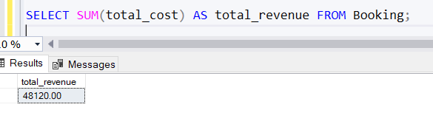

1. Write a SQL query to find the event with the highest ticket sales.

Ans) SELECT TOP 1 event_id, SUM(num_tickets) AS total_tickets_sold FROM Booking

GROUP BY event_id ORDER BY total_tickets_sold DESC;

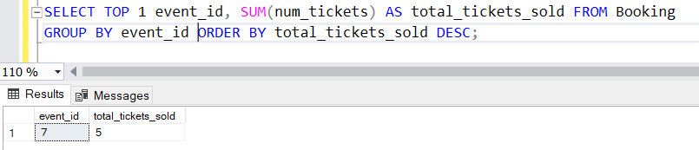

1. Write a SQL query to Calculate the Total Number of Tickets Sold for Each Event.

Ans) SELECT event_id, SUM(num_tickets) AS total_tickets_sold

FROM Booking GROUP BY event_id;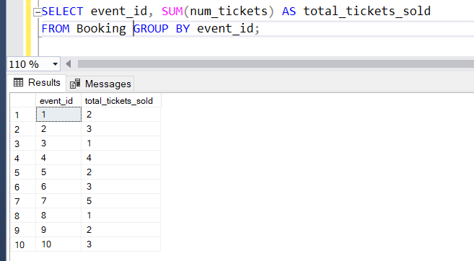

1. Write a SQL query to Find Events with No Ticket Sales.

Ans) SELECT event_id, event_name FROM Event

WHERE event_id NOT IN (SELECT DISTINCT event_id FROM Booking);

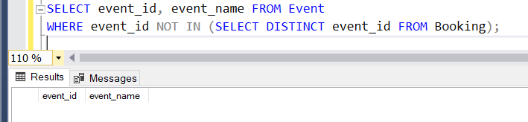

1. Write a SQL query to Find the User Who Has Booked the Most Tickets.

Ans) SELECT TOP 1 c.customer_id, c.customer_name, COUNT(b.booking_id) AS total_tickets_booked FROM Customer c

JOIN Booking b ON c.customer_id = b.customer_id

GROUP BY c.customer_id, c.customer_name

ORDER BY total_tickets_booked DESC;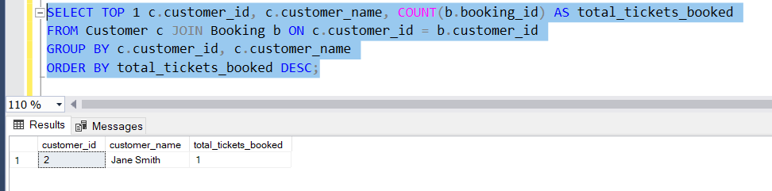

1. Write a SQL query to List Events and the total number of tickets sold for each month.

Ans) SELECT MONTH(booking_date) AS month, event_id, SUM(num_tickets) AS total_tickets_sold FROM Booking GROUP BY MONTH(booking_date), event_id;

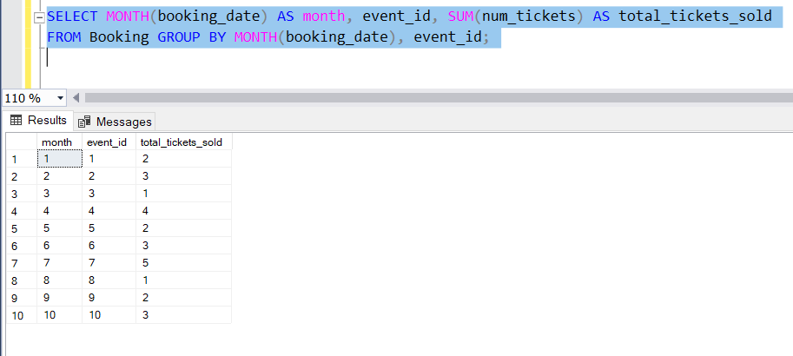

1. Write a SQL query to calculate the average Ticket Price for Events in Each Venue.

Ans) SELECT v.venue_id, v.venue_name, AVG(e.ticket_price) AS average_ticket_price

FROM Venu v JOIN Event e ON v.venue_id = e.venue_id

GROUP BY v.venue_id, v.venue_name;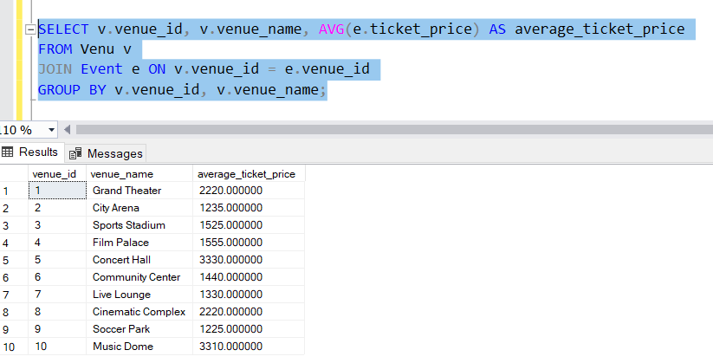

1. Write a SQL query to calculate the total Number of Tickets Sold for Each Event Type.

Ans) SELECT event_type, SUM(num_tickets) AS total_tickets_sold

FROM Event JOIN Booking ON Event.event_id = Booking.event_id

GROUP BY event_type;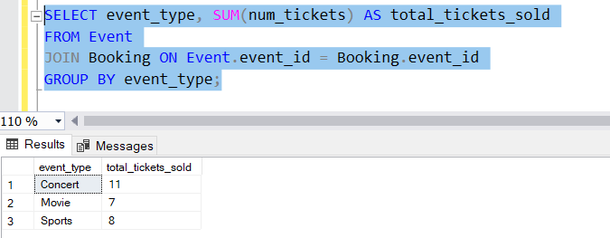

1. Write a SQL query to calculate the total Revenue Generated by Events in Each Year.

Ans) SELECT YEAR(booking_date) AS year, SUM(total_cost) AS total_revenue

FROM Booking GROUP BY YEAR(booking_date);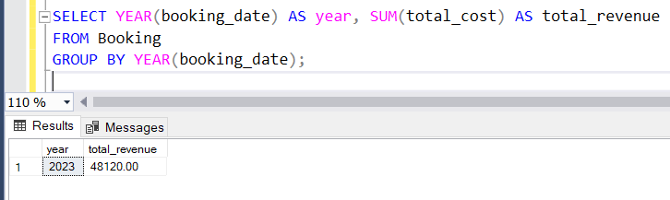

1. Write a SQL query to list users who have booked tickets for multiple events.

Ans) SELECT c.customer_id, c.customer_name

FROM Customer c

JOIN Booking b ON c.customer_id = b.customer_id

GROUP BY c.customer_id, c.customer_name

HAVING COUNT(DISTINCT b.event_id) > 1;

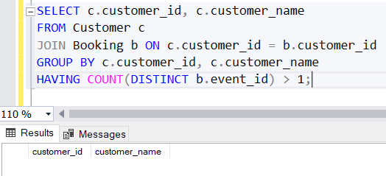

1. Write a SQL query to calculate the Total Revenue Generated by Events for Each User.

Ans) SELECT c.customer_id, c.customer_name, SUM(total_cost) AS total_revenue

FROM Customer c JOIN Booking b ON c.customer_id = b.customer_id

GROUP BY c.customer_id, c.customer_name;

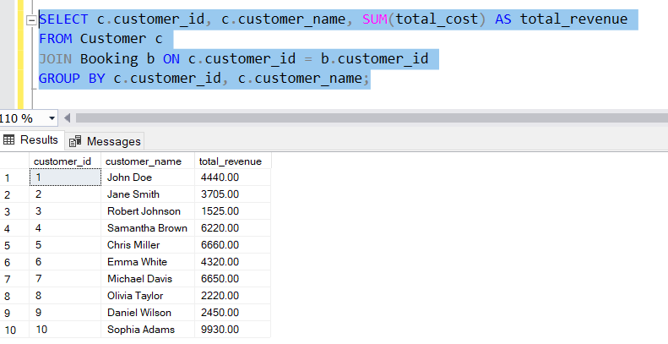

1. Write a SQL query to calculate the Average Ticket Price for Events in Each Category and Venue.

Ans) SELECT v.venue_id, v.venue_name, e.event_type, AVG(e.ticket_price) AS average_ticket_price FROM Venu v

JOIN Event e ON v.venue_id = e.venue_id

GROUP BY v.venue_id, v.venue_name, e.event_type;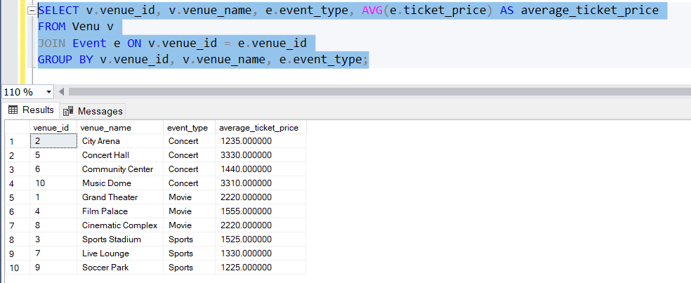

1. Write a SQL query to list Users and the Total Number of Tickets They've Purchased in the Last 30 Days.

Ans) SELECT c.customer_id, c.customer_name, COUNT(b.booking_id) AS total_tickets_purchased

FROM Customer c

JOIN Booking b ON c.customer_id = b.customer_id

WHERE b.booking_date >= DATEADD(DAY, -30, GETDATE())

GROUP BY c.customer_id, c.customer_name;

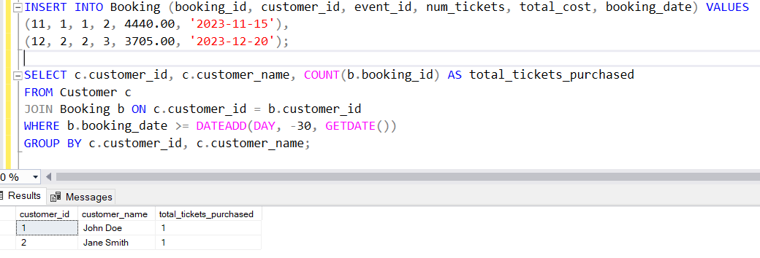

# Tasks 4: Subquery and its types

1. Calculate the Average Ticket Price for Events in Each Venue Using a Subquery.

Ans) SELECT venue_id, venue_name, (

SELECT AVG(ticket_price)

FROM Event

WHERE venue_id = v.venue_id

) AS average_ticket_price FROM Venu v;

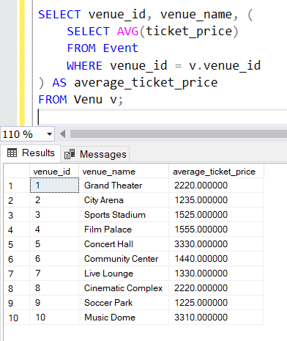

1. Find Events with More Than 50% of Tickets Sold using subquery.

Ans) SELECT event_id, event_name FROM Event

WHERE (

SELECT SUM(num_tickets)

FROM Booking

WHERE Booking.event_id = Event.event_id

) > 0.5 * total_seats;

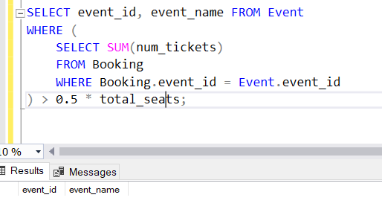

1. Calculate the Total Number of Tickets Sold for Each Event.

Ans) SELECT event_id, event_name, (

SELECT SUM(num_tickets) FROM Booking

WHERE Booking.event_id = Event.event_id

) AS total_tickets_sold FROM Event;

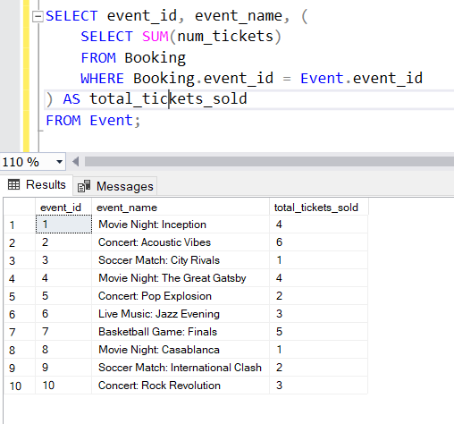

1. Find Users Who Have Not Booked Any Tickets Using a NOT EXISTS Subquery.

Ans) SELECT customer_id, customer_name FROM Customer c

WHERE NOT EXISTS (

SELECT 1

FROM Booking b

WHERE b.customer_id = c.customer_id );

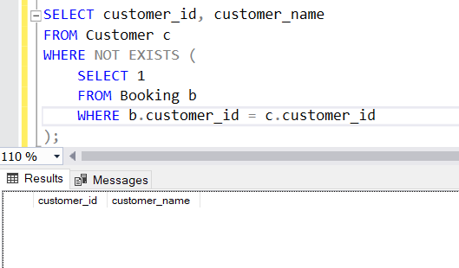

1. List Events with No Ticket Sales Using a NOT IN Subquery.

Ans) SELECT event_id, event_name FROM Event

WHERE event_id NOT IN (

SELECT DISTINCT event_id

FROM Booking );

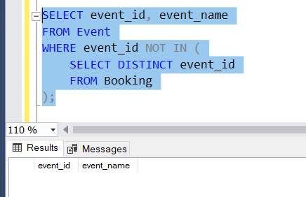

1. Calculate the Total Number of Tickets Sold for Each Event Type Using a Subquery in the FROM Clause.

Ans) SELECT event_type, SUM(total_tickets_sold) AS total_tickets_sold

FROM ( SELECT event_type, event_id, (

SELECT SUM(num_tickets)

FROM Booking

WHERE Booking.event_id = Event.event_id) AS total_tickets_sold

FROM Event ) AS Subquery GROUP BY event_type;

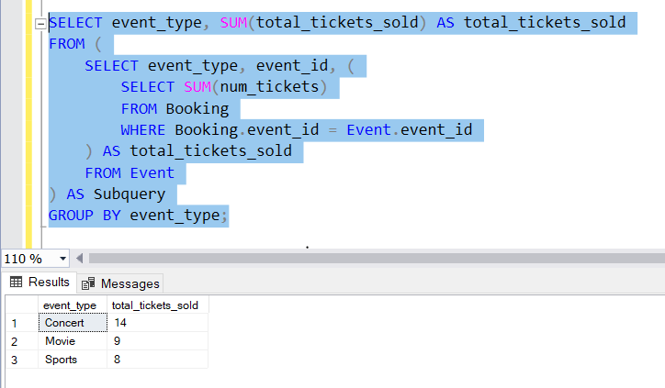

1. Find Events with Ticket Prices Higher Than the Average Ticket Price Using a Subquery in the WHERE Clause.

Ans) SELECT event_id, event_name, ticket_price FROM Event

WHERE ticket_price > (

SELECT AVG(ticket_price) FROM Event );

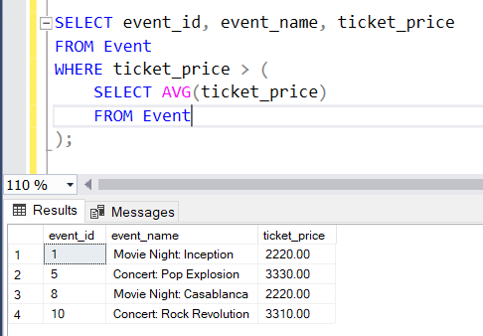

1. Calculate the Total Revenue Generated by Events for Each User Using a Correlated Subquery.

Ans) SELECT customer_id, customer_name, (

SELECT SUM(total_cost) FROM Booking

WHERE Booking.customer_id = c.customer_id

) AS total_revenue FROM Customer c;

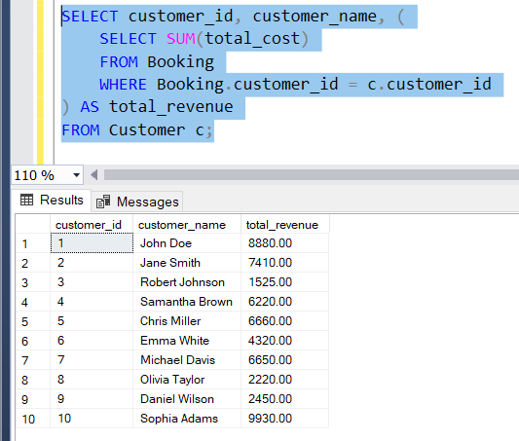

1. List Users Who Have Booked Tickets for Events in a Given Venue Using a Subquery in the WHERE Clause.

Ans) SELECT customer_id, customer_name

FROM Customer WHERE EXISTS (

SELECT 1 FROM Booking

JOIN Event ON Booking.event_id = Event.event_id

WHERE Event.venue_id = 1

AND Booking.customer_id = Customer.customer_id );

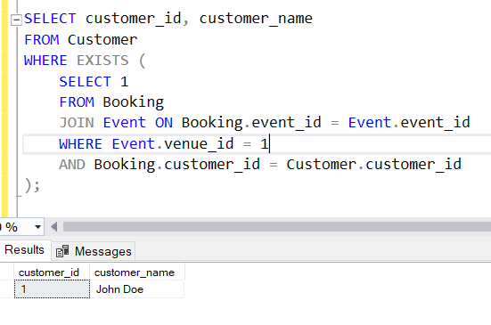

1. Calculate the Total Number of Tickets Sold for Each Event Category Using a Subquery with GROUP BY.

Ans) SELECT event_type, SUM(total_tickets_sold) AS total_tickets_sold

FROM ( SELECT event_type, (

SELECT SUM(num_tickets) FROM Booking

WHERE Booking.event_id = Event.event_id

) AS total_tickets_sold FROM Event

) AS Subquery GROUP BY event_type;

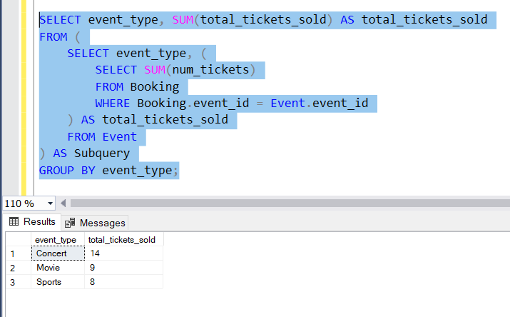

1. Find Users Who Have Booked Tickets for Events in each Month Using a Subquery with DATE_FORMAT.

Ans) SELECT customer_id, customer_name FROM Customer c

WHERE EXISTS ( SELECT * FROM Booking b

WHERE b.customer_id = c.customer_id

AND FORMAT(b.booking_date, 'yyyy-MM') = '2023-01' -- Replace with the desired month );

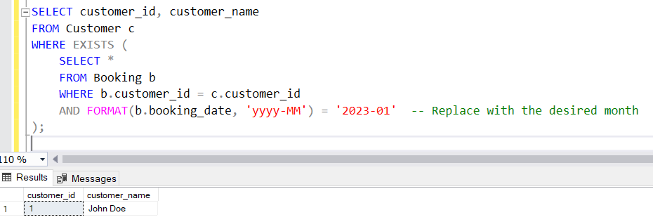

1. Calculate the Average Ticket Price for Events in Each Venue Using a Subquery

Ans) SELECT venue_id, venue_name, (

SELECT AVG(ticket_price)

FROM Event

WHERE venue_id = v.venue_id

) AS average_ticket_price FROM Venu v;

